UNIT-V

POTENTIOMETERS

1. INTRODUCTION:
A potentiometer is an instrument designed to measure an unknown voltage by comparing it with a known voltage. The known voltage may be supplied by a standard cell or any other known voltage reference source . Measurements using comparison methods are capable of a high degree of accuracy because the result obtained does not depend upon the actual deflection of a pointer, as is the case in deflection methods, but only upon the accuracy with which the voltage of the reference source is known. Another advantage of the potentiometers is that since a potentiometer makes use of a balance or null condition, no current flows and hence no power is consumed in the circuit containing the unknown emf when the instrument is balanced. Thus the determination of voltage by a potentiometer is quite independent of the source resistance. Since a potentiometer measures voltage, it can also be used to detect current simply by measuring the voltage drop produced by the unknown current passing through a known standard resistance. The potentiometer is extensively used for a calibration of voltmeters and ammeters and has in fact become the standard for the calibration of these instruments. For the above mentioned advantages the potentiometer has become very important in the field of electrical measurements and calibration.

2. Basic Potentiometer Circuit: The principle of operation of all potentiometers is based on the circuit of Fig. 4.1, which shows the schematic diagram of the basic slide wire potentiometer.
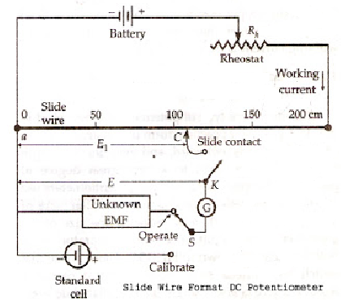
With switch 'S' in the "operate" position and the galvanometer key K open, the battery supplies the "working current" through the rheostat R and the slide wire. The working current through the slide wire may be varied by changing the rheostat setting. The method of measuring the unknown voltage, E, depends upon finding a position for the sliding contact such the galvanometer shows zero deflection, i.e., indicates null condition, when the galvanometer key, K, is closed. Zero galvanometer deflection or a null means that the unknown voltage, E, is equal to the voltage drop El' across portion ac of the slide wire. Thus determination of the value of unknown voltage now becomes a matter of evaluating the voltage drop E1 along the portion ac oof the slide wire.
The slide wire has a uniform cross-section and hence uniform resistance along its entire length. A calibrated scale in cm and fractions of cm, is placed along the slide wire so that the sliding contact can be placed accurately at any desired position along the slide wire. Since the resistance of slide wire is known accurately, the voltage drop along the slide wire can be controlled by adjusting the value of working current. The process of adjusting the working current so as to match the voltage drop across a portion of sliding wire against a standard reference source is known as"Standardization".

Standardization:
The procedure for standardization of the potentiometer is illustrated by the following example:
The slide wire of Fig. 4.1 has a total length of 200 cm and a resistance of 200 ohms. The emf of the standard cell is 1.0186 V. Switch 'S' is thrown to "calibrate" position and the sliding contact is placed at 101.86 cm mark on the slide wire scale. The rheostat Rh is now adjusted so as to vary the working current. This adjustment is carried on till the galvanometer shows no deflection when key 'K' is pressed. Under these conditions, the voltage drop along the 101.86 cm portion of the slide wire is equal to standard cell voltage of 101.86 V. Since the 101.86 cm portion of the slide wire has a resistance of 101.86 ohms, the working current in fact has been adjusted to a value ;
(1.0186 /101.86)x 1000 = 10 mA.
The voltage at any point along the slide wire is proportional to the length of slide wire. This voltage is obtained by converting the calibrated length into the corresponding voltage, simply by placing the decimal point in the proper position e.g. 153.6 cm. = 1.536 V. If the potentiometer has been calibrated once, its working current is never changed.

3.Crompton's D.C Potentiometer:
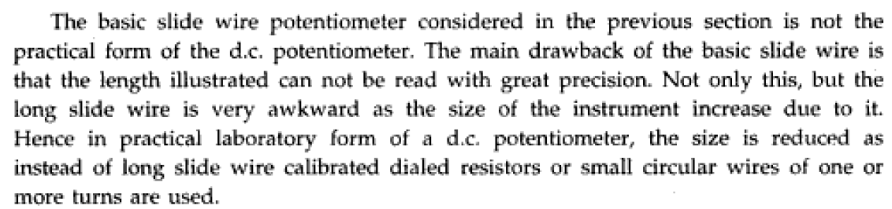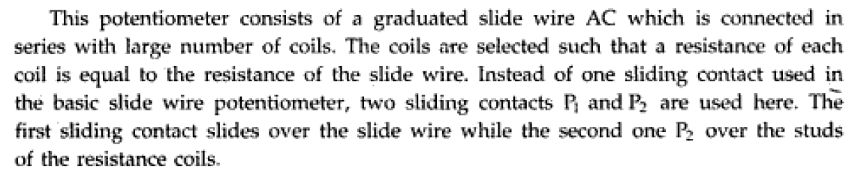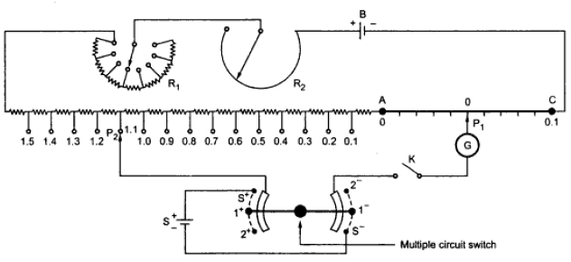
Fig.4.2. Crompton's D.C potentiometer
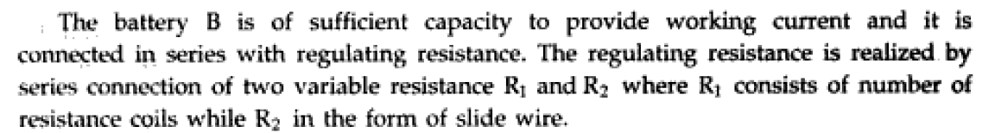
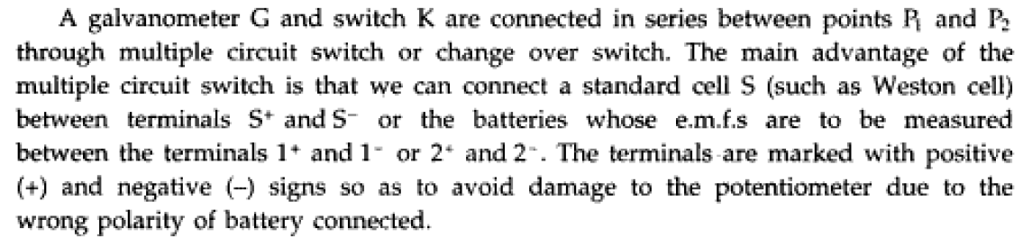
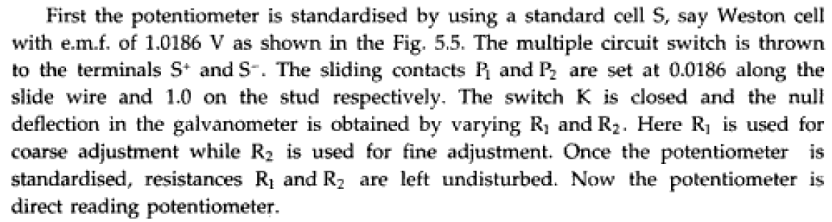
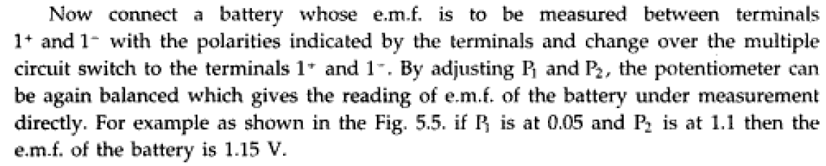
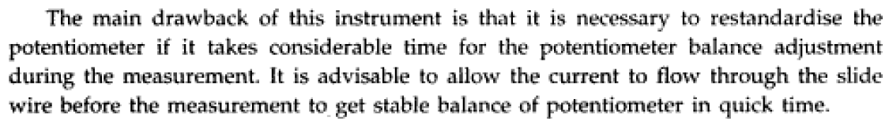

4.Volt-Ratio Box: 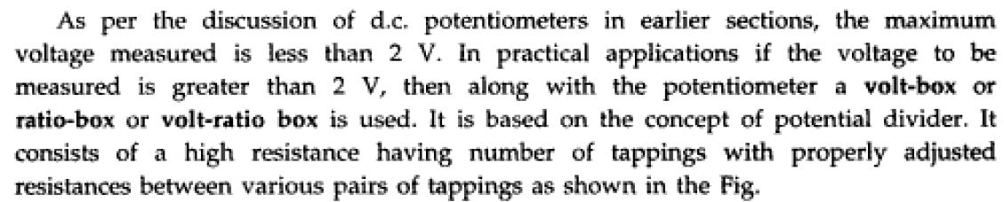
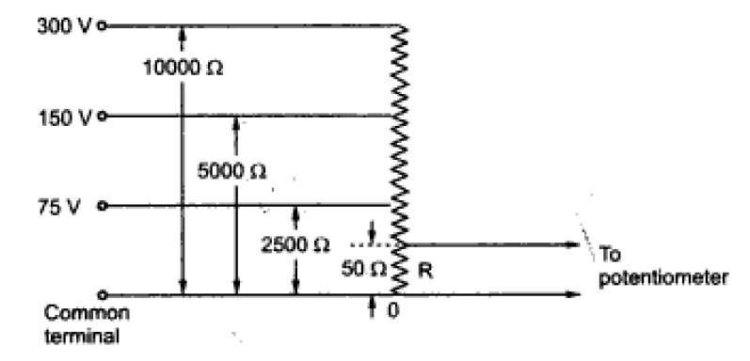
4.3 Volt-Ratio Box
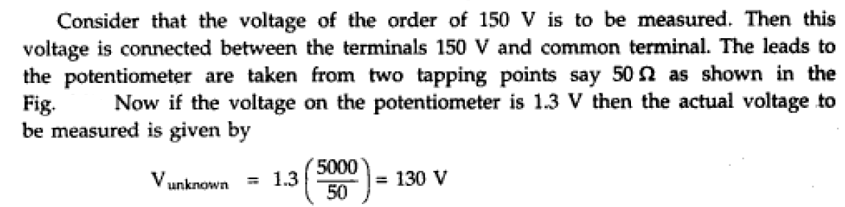
4.Applications of D.C Potentiometers:
(i) Calibration of Voltmeter:
The practical set up for calibration is shown in Fig's.

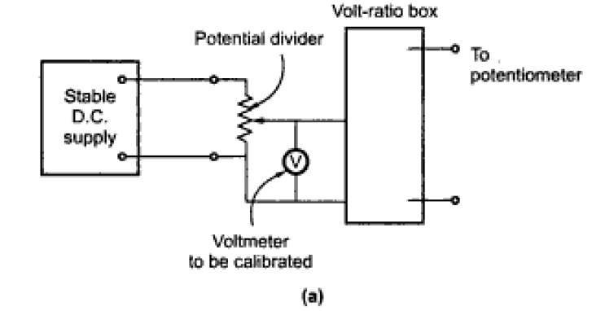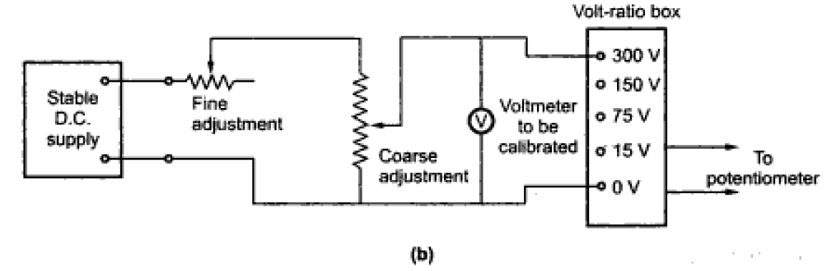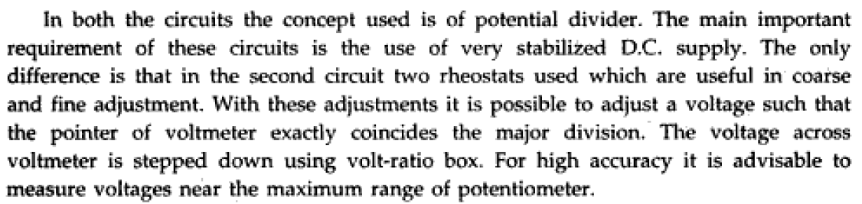
Let the reading of voltmeter indicated be V_{ind}. The actual voltage measured using potentiometer is given by,
V_{act}=(Potentiometer Reading)/(V.R.box ratio)
If these two readings are not matching, a positive or negative error is indicated. The percentage error can be calculated as
%error=((V_{ind}-V_{act})/(V_{ind}))*100
A calibration curve can be drawn by plotting percentage error against the indicated voltage.

(ii) calibration of Wattmeter:

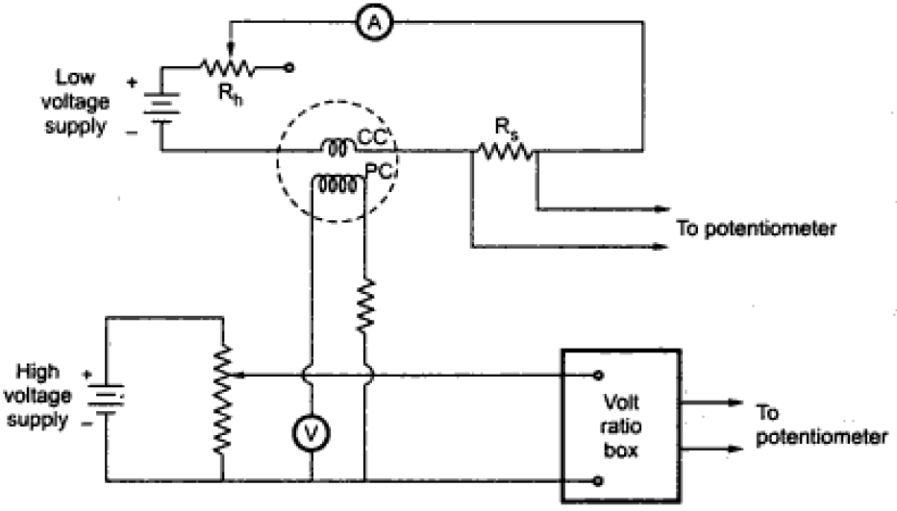
4.4. calibration of wattmeter
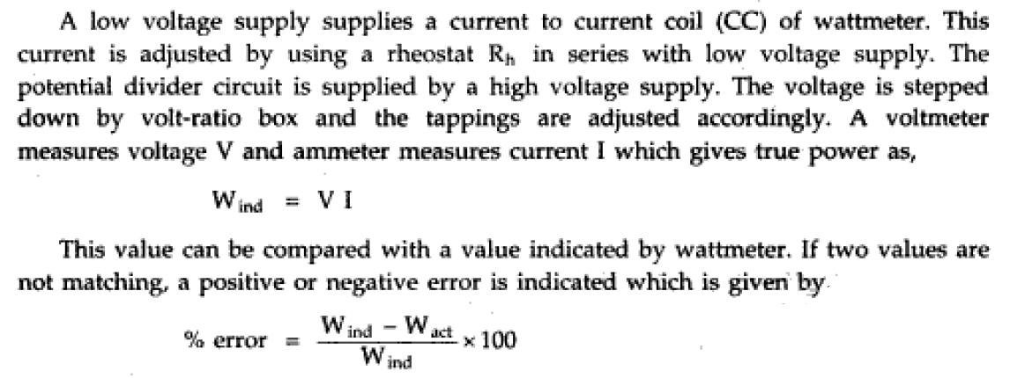
(iii) Measurement of Resistance:
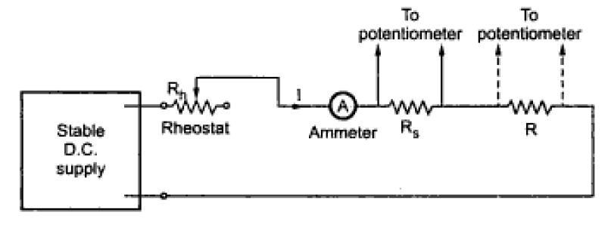
4.5 Measurement of Resistance

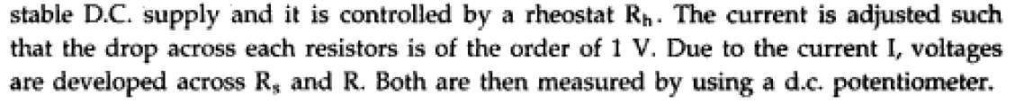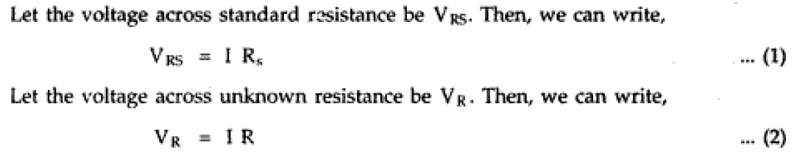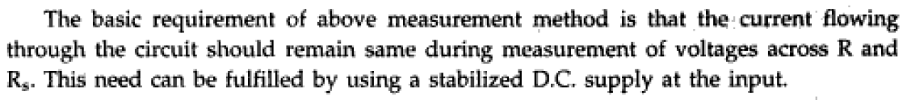
(iv)Measurement of Power:
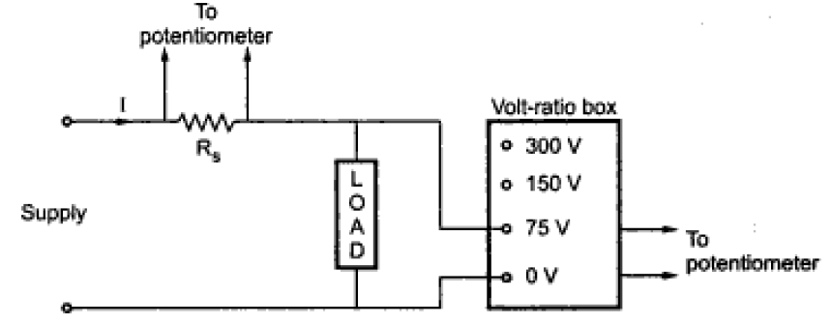

4.6. Measurement of power
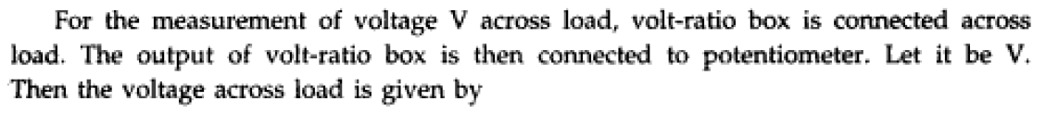
Thus from above equations the power is given by


5.A.C Potentiometers:
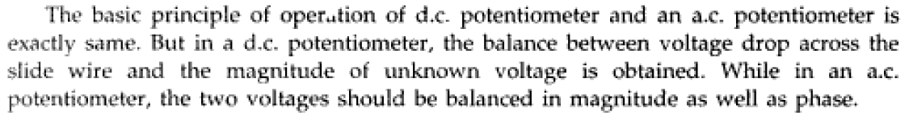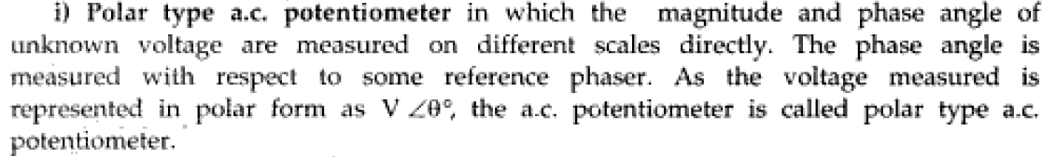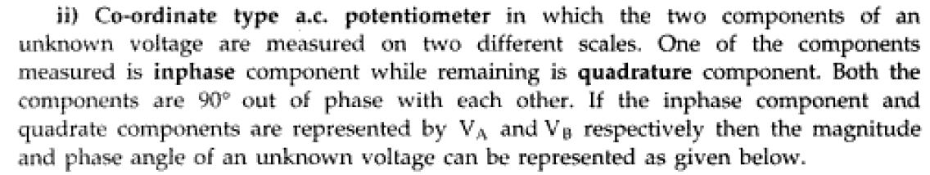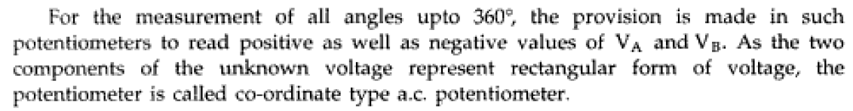

Basic requirements of A.C.Potentiometers:
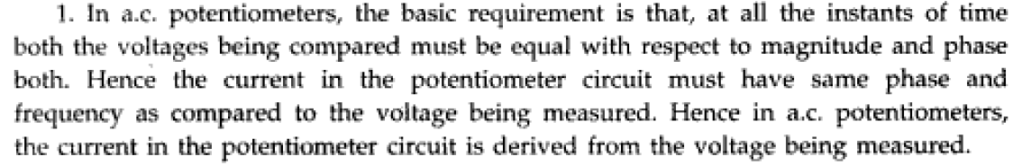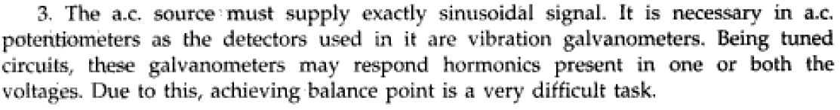

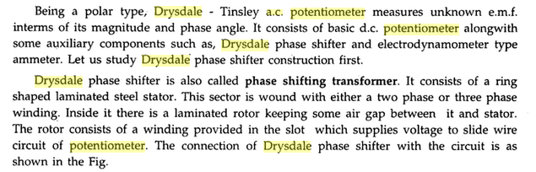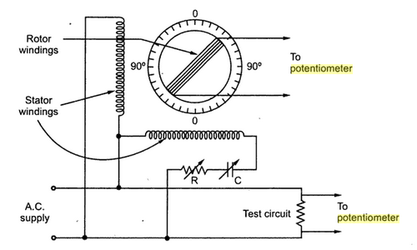
4.7 Drysdale -Tinsley polar type A.C Potentiometer
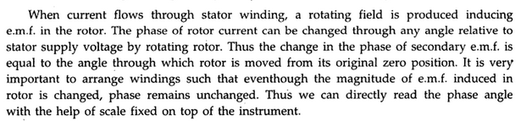
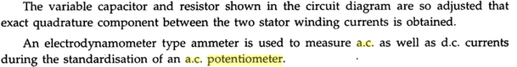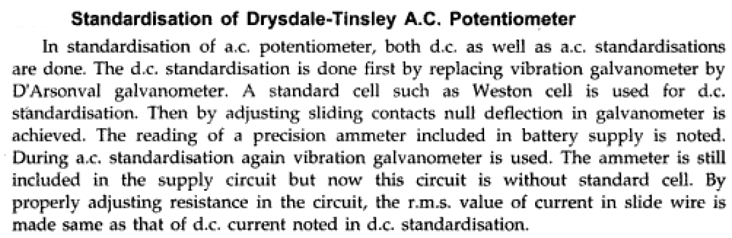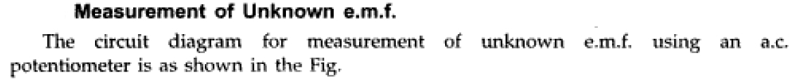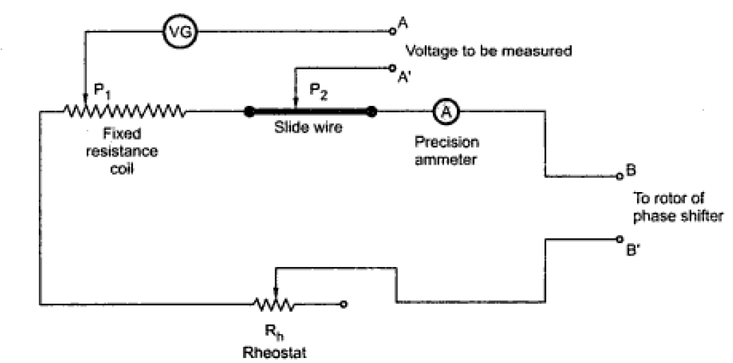
4.8.Measurement of unknown E.M.F
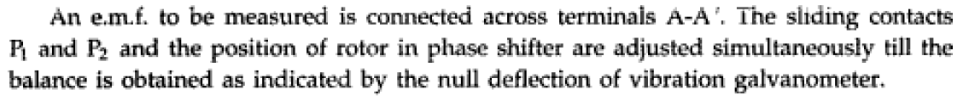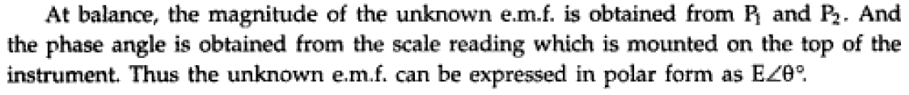

Gall-Tinsley co-ordinate AC Potentiometer
In coordinate AC potentiometer, two separate potentiometers are caged in one circuit as shown in the figure. The first one is named as the in-phase potentiometer which is used to measure the in-phase factor of an unknown e.m.f. and the other one is named as quadrature potentiometer which measures quadrature part of the unknown e.m.f. the sliding contact AA’ in the in-phase potentiometer and BB’ in quadrature potentiometer are used for obtaining the desired current in the circuit. By adjusting rheostat R and R’ and sliding contacts, the current in the quadrature potentiometer becomes equal to the current in the in-phase potentiometer and a variable galvanometer shows the null value. S₁ and S₂ are signs changing switches which are used to change the polarity of the test voltage if it is required for balancing the potentiometer. There are two step-down transformers T₁ and T₂ which isolate potentiometer from the line and give an earthed screens protection between the winding. It also supplies 6 volts to potentiometers.
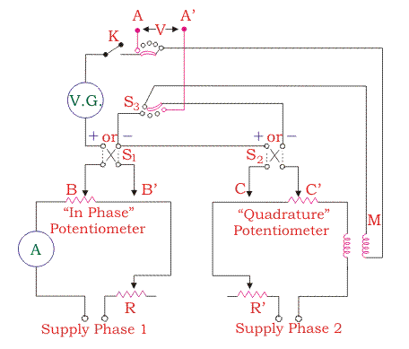
4.9.Gall-Tinsley Coordinate type AC Potentiometer

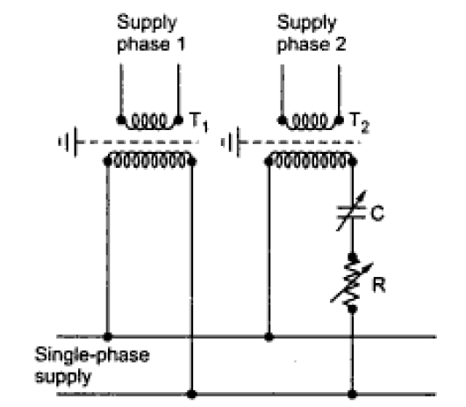
4.10.Phase Splitting Circuit

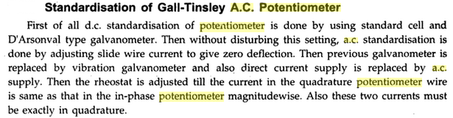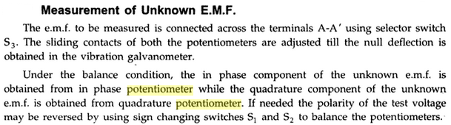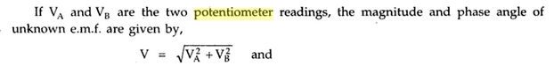

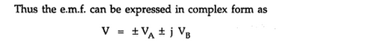

6.Applications of A.C Potentiometers

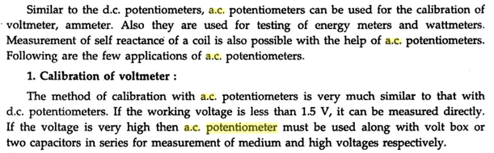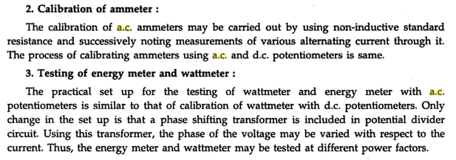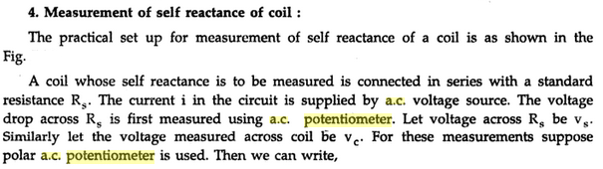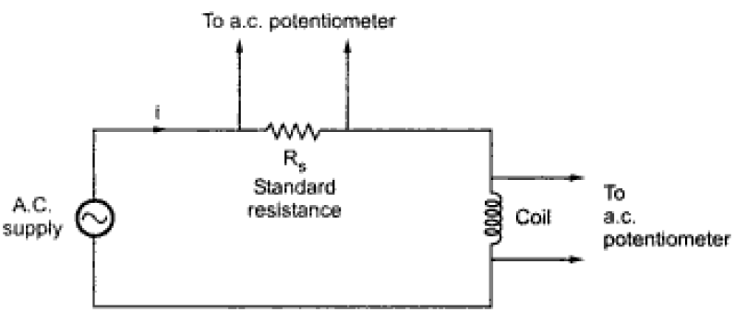
4.11Measurement of Reactance of a coil
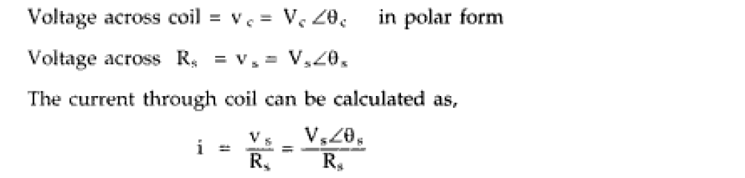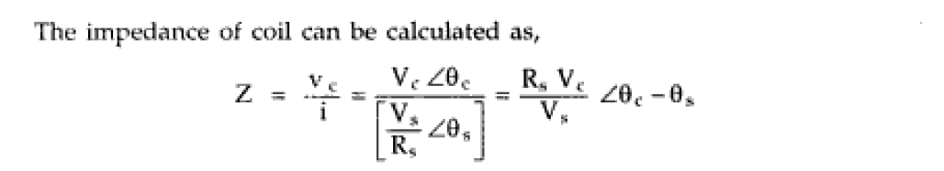
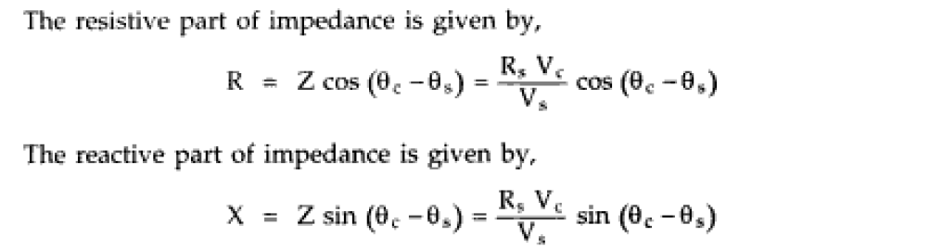
The above Equation represent the Reactance of coil.

